**1. Interactive dashboards**

We finished the last lesson looking at some graphs, so let's talk a little more about visualization.

**2. One picture...**

One picture is worth a thousand words, they say. Based on what we saw in the previous lesson, we would tend to agree. However, there are a few things to pay attention to, to ensure your chart is easily understandable and straight to the point.

**3. Use color purposefully**

For example, you should use color purposefully. Remember this graph? Count of launches by year, pretty straightforward.

**4. Use color purposefully**

What about this one?

**5. Use color purposefully**

So colorful, so much better!

**6. Use color purposefully**

Wrong! Granted, it's aesthetically pleasing, but it's also confusing. What do the colors correspond to? Nothing. We're just counting launches per year. One color is enough.

**7. Colorblindness**

You should also be mindful of colorblindness. You may distinguish red and green very well, but some people don't, and more than you think. You can find a lot of information on colorblindness online, as well as palettes of colors that are accessible to colorblind people.

**8. Readable fonts**

You should also use readable fonts. Sans-serif ones are easier to read. There are nicer fonts available, sure, but your readers should focus on your viz message, not on the font.

**9. Label, label, label**

An image is worth a thousand words, but words do help. Your graphs should always have a title, so we know what we're looking at; the x and y axis should have labels, otherwise they could be anything; and you should provide a legend if you use colors and patterns, so that we know what they refer to.

**10. Axes**

There are some cases when you can start your axes higher than zero, if you want to zoom in on evolution, for example. But it can be misleading. Here, it looks like Obamacare enrollment is far from the goal,

**11. Axes**

when it's actually close.

**12. And the award goes to...**

Follow these advises, and you should prevent your readers the confusion that comes with badly designed graphs like this one,

**13. Honorable mention**

Or this one. I don't know where to start.

**14. Question**

If a picture is worth a thousand words, then what is worth a thousand pictures?

**15. A dashboard!**

A dashboard! Well, technically, a dashboard of a few pictures is enough already. My point is, showing several pictures together can be more insightful than looking at them separately, or trying to pack all the insights in one graph. Your car dashboard indicates the car speed, the motor rotation speed and the proportion of gas left. Individually, these pieces of information are useful. But together, they paint a much bigger picture and make your trip more safe and more comfortable.

1. 1 Photo by Marek Szturc on Unsplash

**16. Dashboards**

That's what dashboards do: group all the relevant information in one place to make it easier to gather insights and act on them. On this dashboard, any sales person can see not only how sales are progressing this quarter, but also how this progression compares to previous quarters. On top of that, they can keep track of transactions and opportunities, as well as of customer count. They can filter all of this data by software, service or maintenance sales. All of that in one place, customized for their needs!

**17. BI tools**

Business Intelligence tools let you clean, explore, visualize data, and build dashboards, without requiring any programming knowledge. Such tools are Tableau, Looker, or Power BI. Of course, you can also do that programmatically using Python, R, or even JavaScript.

**18. Next level**

The next level is to make your visualization interactive, which BI tools make really easy. It lets you display more targeted information when hovering over an element, like you can see here. We also talked about filters: here the user can filter on the type of sales and the quarter. Giving power to the user is a great way to engage them.

**19. Let's practice!**

Home stretch to Chapter 4!

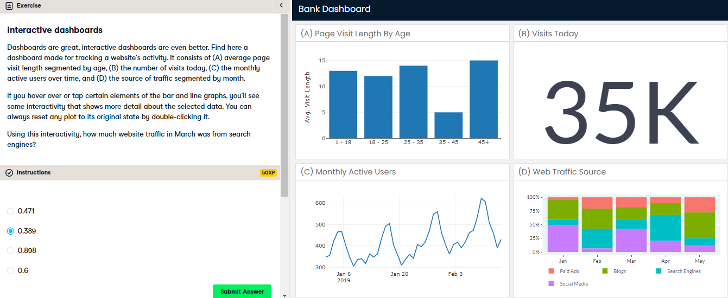

Nice! Pretty handy, right? Interactivity allows us to plot more without having to show all the values clearly at once.

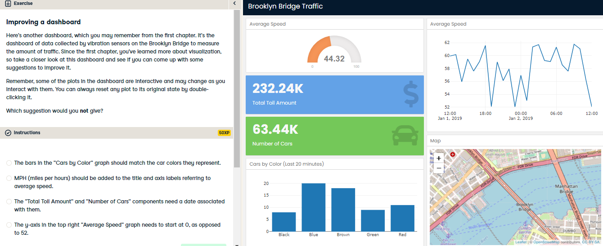

Nice job! In the video, we saw cases of misleading axes, but this isn't the case here. We know that average speed is going to be more than 0 and by starting at 52, we can better see the changes in speed as they occur between 52 and 62.